16th November 2012

**First-Phase Tree-Planting Ceremony Held at YOKOHAMA´s Tyre Production and Sales Company in Suzhou, China**

YOKOHAMA announced today that on 27th October 2012 its group company in China, Suzhou YOKOHAMA Tyre Co., Ltd., held a first-phase tree-planting ceremony on its premises in the Suzhou New District, Suzhou City, Jiangsu Province, as part of the YOKOHAMA Forever Forest Project. On the day of the event, 250 people, including Chairman and President Koichi Tanaka of YOKOHAMA Rubber (China) Co., Ltd., the holding company for its operations in China, and President Shigeru Nakano of Suzhou YOKOHAMA Tyre, employees and their families, and representatives of the local environmental protection bureau, participated. They planted about 5,000 trees of 20 varieties, including camphor trees, Japanese privet trees and chestnut trees, according to the method designed by Dr. Akira Miyawaki (a plant ecologist and professor emeritus of YOKOHAMA National University). Established in April 2006 as a wholly owned subsidiary of YOKOHAMA Rubber (China), Suzhou YOKOHAMA Tyre produces and sells tyres for trucks and buses.

YOKOHAMA Rubber launched the YOKOHAMA Forever Forest Project in 2007 and continues toward its goal of planting 500,000 trees at domestic and overseas production sites in anticipation of the company’s 100th anniversary in 2017. In China, three locations – Hangzhou YOKOHAMA Tyre Co., Ltd., producer and seller of tyres, YOKOHAMA HAMATITE (Hangzhou) Co., Ltd., producer and seller of sealants for passenger cars, and YOKOHAMA Hoses & Coupling (Hangzhou) Co., Ltd., producer and seller of a variety of hoses – have jointly held tree-planting ceremonies three times since November 2008. Shandong YOKOHAMA Rubber Industrial Products Co., Ltd., producing and selling conveyor belts, has staged two such events since August 2011. With the tree planting at Suzhou YOKOHAMA Tyre, total trees planted by YOKOHAMA Rubber group companies reached around 275,330 as of October 2012.

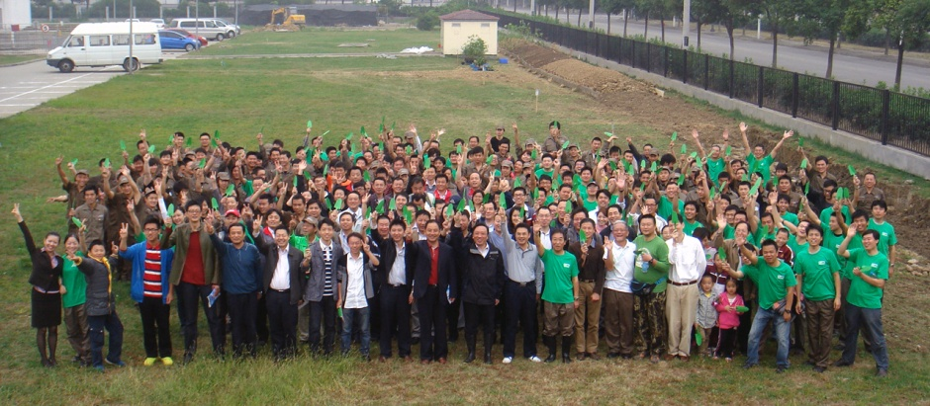

*Participants in the tree-planting ceremony*